Please knock here to collect our food donation

[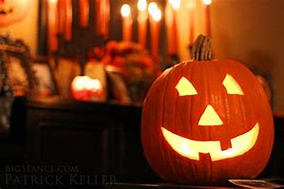](https://www.bing.com/images/search?view=detailV2&ccid=OogVnW/B&id=1CC2181088D83376DC32F277F4BE762C3BED4F3E&thid=OIP.-cGqN2XMAKxX3LJilpff7AHaE8&mediaurl=https://thebigseance.files.wordpress.com/2014/10/halloween_jack-o-lantern_2014_big_seance.jpg&exph=3456&expw=5184&q=halloween&simid=608025440109790887&selectedIndex=44)