Kilndown Village Newsletter
When David Denton arrived as the new Headmaster at the primary school in 1981 the village had been without its own Parish Magazine for decades. News of events was spread by word of mouth or bill posters. The first Kilndown Village Newsletter was published in February 1982 and for over 40 years, every resident in the parish of Kilndown has received a free copy. David died on 15 May, the day before his 80th Birthday and a great void has been left in the world of communication (and much more) in Kilndown and Goudhurst.

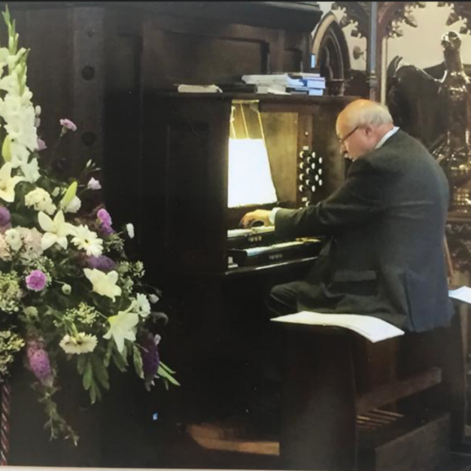

The Tea Room is back! Every Saturday until 29 July, from 10am to 12 noon. Do the shopping and then have a cup of coffee, slice of cake and a chat.
Following on from the Gardening Club talk on swifts, given by Cheryl Mason from High Weald Swifts, the QC has purchased three swift boxes to be placed on the apex of building – bus shelter end.
Don’t forget we have a collection box for used ink cartridges. And a reminder we have a selection of Eco-Friendly cleaning products on a refill basis, just bring a bottle.
CHRIST CHURCH FLOWERS
A Cake Sale was held a while ago, raising just over £200 to provide flowers in church for Easter. Not a lot of this money was used and was kept back to spend on flowers for the Coronation of HM King Charles III on 6 May. Many thanks to all who baked, washed up, arranged, swept up and all those other behind the scenes ‘things’ that made all this possible. There are quite a few dates spare on the Flower Rota, if anyone else would like to join the ‘team’. We are endeavouring to reduce the use of Oasis (other floral foams are available) to help the environment, if anyone has large urn/cylinder/ square vases that may be suitable to arrange flowers in, on a ‘church scale’ please get in touch with Lynda.
1
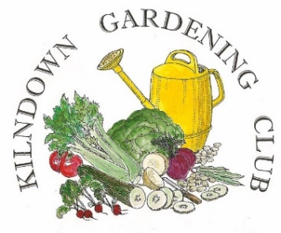 There was a miniscule audience for the 4 May evening talk, which was probably just as well, as the speaker went off on a tangent and the talk was not what I, or anyone else expected! The next meeting was to have taken place on 1 June, when Dan Luscombe would have spoken about the work at the National Pinetum at Bedgebury. Unfortunately, Dan had to cancel, but we are hoping to do a bit of swopping about and get him later in the year as much interest was being shown about the evening.
Our Plant Sale on 20 May was well supported, with the takings on the day being £320, this has now risen to £335. Thank you to all who donated plants and bought plants.
The next event is the A Summer Evening Show on Thursday 6 July. Details available from the Quarry Centre Saturday Shop or email lyndashepherd549@gmail.com

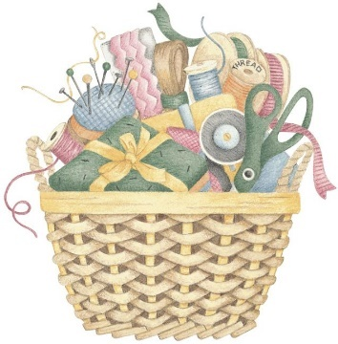QUILTING GROUP
This small group meet at the Quarry Centre on Tuesdays between 10am and 12 noon. Do you need help with knitting, crochet, sewing? Pop in and ask, there’s bound to be someone who can help!

VILLAGE HALL
The Village Hub is taking a break for the summer, with the last session on Tuesday 13 June and will re-convene on Tuesday 12 September.

CORONATION TEA PARTY
Fine weather on 7 May meant that dozens of families gathered on the Millennium Green in celebration of King Charles’ III Coronation. Complimentary cream teas, wine and beer were appreciated by all. Thank you to Cellar Head and Weekes Bakery. The village photograph taken at the Tea Party will be available to view on the Village Hall website soon, www.kilndownvillagehall.org

2
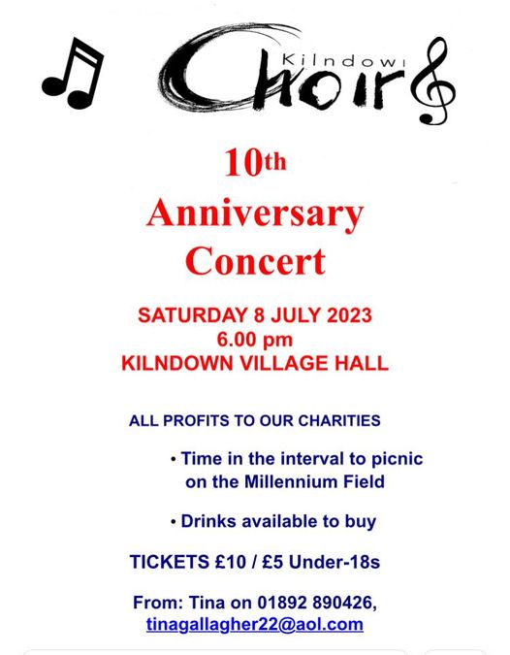

CORONATION TEA PARTY
Fine weather on 7 May meant that dozens of families gathered on the Millennium Green in celebration of King Charles’ III Coronation. Complimentary cream teas, wine and beer were appreciated by all. Thank you to Cellar Head and Weekes Bakery. The village photograph taken at the Tea Party will be available to view on the Village Hall website soon, www.kilndownvillagehall.org

Diary Dates
Every Monday – Community Choir – Christ Church 7pm
Every Tuesday - Quilting Group – Quarry Centre 10am - 12 noon
Every Saturday - Quarry Centre Saturday Shop open 9am – 12 noon
Thursday 6 July – Summer Evening Show – Quarry Centre
Saturday 8 July - Kilndown Choir Anniversary Concert – 6pm Kilndown Village Hall
3
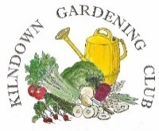Summer Evening Flower Show
Thursday 6 July – Quarry Centre 7.15pm
Entries to be staged between 6pm & 6.45pm
Schedules available QC Saturday Shop
Further details – lyndashepherd549@gmail.com
KILNDOWN EDUCATION TRUST

Kilndown Education Trust is a charity formed in 1994 after the closure of Kilndown Primary School. The Trust has funds available for young people up to the age of 25 living in the parish of Kilndown who might benefit from financial support for any aspect of their education. Grants are not means-tested.

We continue to support our two local primary schools where Kilndown children are taught. Grants towards various educational extra-curricula activities, including university textbooks, music and swimming lessons, were also made to 44 individual students last year (2022). If you are not sure if you qualify, please feel free to contact the Secretary.

The next round of grants will be awarded in September 2023; the closing date for applications is September 1st 2023.

Hilary Bird (Secretary)
Rogers Rough
Chicks Lane
Kilndown
Kent TN17 2RP

telephone: 01892 890554
e-mail: hilarybird7@gmail.com

4
THANKSGIVING SERVICE FOR DAVID DENTON
Wednesday 28th June
2pm, Christ Church
A Thanksgiving service for the life of David Denton will be held at Christ Church, Kilndown on Wednesday 28th June at 2pm and will include an interment of his ashes in the churchyard. The service will be followed by refreshments in the church. All are welcome. Please share cars where possible to reduce parking difficulties.
Photographs and memories to be included in tributes can be passed to or emailed to Revd Rachel rachel.robertson@gkchurch.org
If you would like to help with refreshments please contact Della dellafox@btinternet.com or call / WhatsApp 07554232770
David was passionate about installing a loo at Christ Church. Donations in his memory for the church loo fund can be made to Kilndown PCC, Account: 00082841 Sort code: 30-92-36 reference ‘David Denton.’

Kilndown in the Past
When David Denton printed his first Newsletter in 1982, there were sixteen entries in the Kilndown Directory: Bell Ringers, Bonfire Society, Chess Club, Cricket Club, Goudhurst & Kilndown History Society, Goudhurst Parish Council, Horticultural Society, Keep Fit, Parent Teacher Association, Parochial Church Council, Petanque Club, Quarry Centre, Quarry Pond, Royal British Legion, Primary School and Village Hall.
There was an article from the Women’s Institute, having held its 62nd Annual Meeting in December 1981, the group had suspended itself for three years. If by the end of that time it could not be restarted with a minimum of 30 members, it would close for ever. (It did).
Fete fever was upon the village! After a Fete in 1977 for the Queen’s Silver Jubilee, Fetes had been run each year since to raise funds for the village hall. Circumstances changed, and in 1982 village organisations were invited to submit requests for grants from the funds raised at that years Fete. These would be assessed by the Fete Committee and their recommendations put forward at the Annual Parish Meeting on 7 April, when the parish would be invited to vote for their choice. Video recordings of some Fetes have come to light, they make interesting viewing!

4

